More information is available via the TOPS Lab ITS Inventory page at http://www.topslab.wisc.edu/its/inventory/

Files and folders described in this document can be found at http://www.topslab.wisc.edu/its/inventory/docs/spatialnet_setup/

Below are the instructions to setup spatialNET Desktop to generate inventory reports

- Install Oracle Client
  - RECOMMENDED: Install Runtime version of the Client. Copy either win32 or win64 zip file to PC, unzip, run setup.exe, select Runtime, change base path to C:\oracle, complete installation
  - Add TOPS-ASBUILTS service to TNS names file (usually in C:\oracle\product\[version]\client_1\network\admin\)

(A sample tnsnames.ora file is included in the Oracle Clients folder. If there is no tnsnames file, just copy the sample file in the NETWORK\ADMIN folder. DO NOT OVERWRITE AN EXISTING TNSNAME FILE)

TOPS-ASBUILTS =
(DESCRIPTION =
(ADDRESS_LIST =
(ADDRESS = (PROTOCOL = TCP)(HOST = transport- asbuilts.cee.wisc.edu)(PORT = 1521))
)
(CONNECT_DATA =
(SERVICE_NAME = itsdb)
)
)

- Install SpatialNET Client
  - Latest client binary is at http://www.topslab.wisc.edu/its/inventory/docs/spatialnet_setup/ (also available from SpatialINFO support website http://www.netsuite.com/portal/home.shtml
  - spatialNET 5.8.exe
NOTE: Must Run as Administrator on Windows 7 (right click on icon before installing)
  - Select spatialNET Desktop during the installation process (spatialNET Desktop does not require AutoCAD installation)

- Configure spatialNET Client
  - Unzip licence_files.zip
  - Copy licence.ini into C:\Program Files\SPATIALinfo\SPATIALnet\bin (or bin64) folder, this will direct the client to use the license server on TOPS-ASBUILTS
  - Copy spatialfm.ini into C:\Program Files\SPATIALinfo\SPATIALnet\dbms folder, this will allow SpatialNET to connect to the database.
  - Alternatively, run C:\Program Files\SPATIALinfo\SPATIALnet\bin\dbed2.exe

Description: WisDOT ITS As-Built Plans
Data Dictionary: spatialfm
Host: transport-asbuilts.cee.wisc.edu
Socket: 1521
Service: tops-asbuilts
Schema: LEAVE BLANK
DB driver: OracleSpatial
Username: dotits
Password: its123

  - Create the System Environment Variable (Control Panel\System and Security\System\Advanced system Settings):
Name: DPRINT_FILENAME
Value: C:\Program Files\Spatialinfo\spatialnet.log

- Configure Reports
  - Unzip reports.zip to:
C:\ProgramFiles\SPATIALinfo\SPATIALnet\python\spatialnet\custom\reports

- Run SpatialNET Desktop
  - Please write to inventory@topslab.wisc.edu for your username and password
  - Click SPATIALnet --> Reports --> Select the report you want to generate

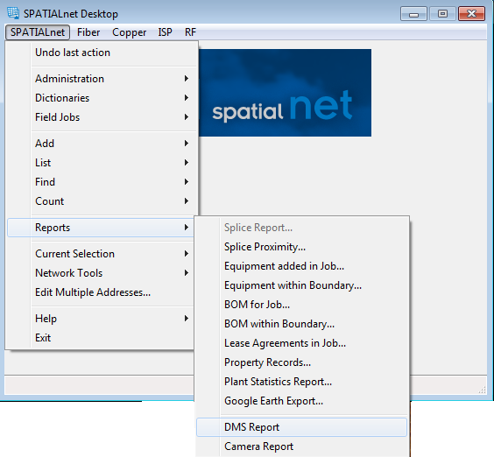

Any other questions should be directed to inventory@topslab.wisc.edu

