To upgrade Spatialnet you need to rename the Spatialnet folder under the C:\Program Files\SPATIALinfo folder.
Then right-click on spatialNET5.8.1_Setup.exe select Run as Administrator.
Once this is done you need to copy your .ini and license.key file from the old spatialNET to the new install into the same folder.
Startup a spatialNET session and this is the only time you will see these panels is when you startup a new version of Spatialnet so it can upgrade the database to the new versions of spatialNET. Select yes if you want to upgrade the database. When this is done you cannot go back to the last version of spatialNET.
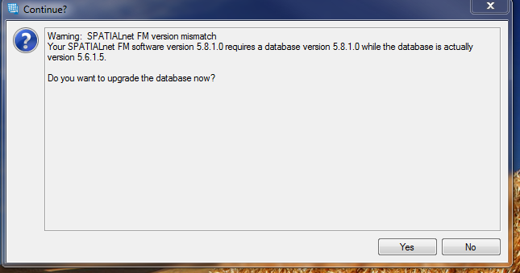
This panel will open and you click the Upgrade DB button. When these scripts finish then check to see what SQL errors you get if any. If any questions just send me the log file and I will look at it.
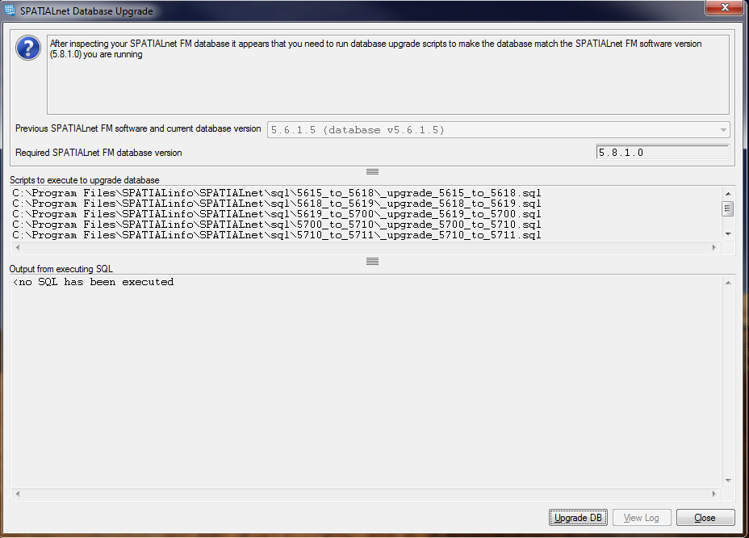
Once you tested that spatialNET is running then you can delete the rename spatialNET folder you did in the first step. Now do the new install on all machines that you want to run spatialNET.

